Attention: U4 to U7 Team Officials
Re: Mill Woods Grassroots Program

Hi Team Officials,
As the first week of the new Mill Woods Grassroots Program, focusing on station rotations, physical literacy and Long Term Player Development, endorsed by Canada Soccer and Alberta Soccer, has ended, the Mill Woods Soccer Directors had a meeting to evaluate it. We want to thank all the input by the Team Officials and parents. As this is a pilot program for Mill Woods Soccer, we are learning how this program works on the outdoor fields for everyone involved.

The Mill Woods Soccer Directors is implementing the following changes to the program.

- All teams are to stay on the same field and not move to another field.
- All teams are to rotate the activities as per the curriculum set forth by the MWSA Technical Director.
- The larger bow nets will be set up and put away by the Technical Trainers. If there are not enough larger bow nets, please keep using the pop up nets.
- For the U7 B (Tues/Thurs) on MM #1-MM #4, when it comes to the last activity (small sided game), play the team beside you but make the field larger as per the diagram:

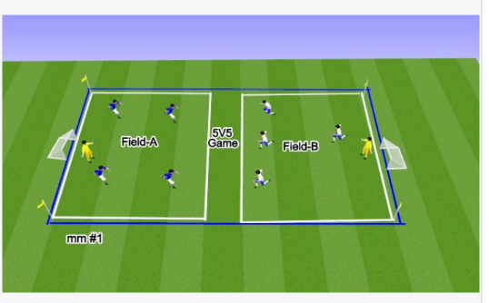

- For the U7 G teams on MM #5 - #6, when it comes to the last activity (small sided game), play the team beside you but make the field larger as per the diagram:
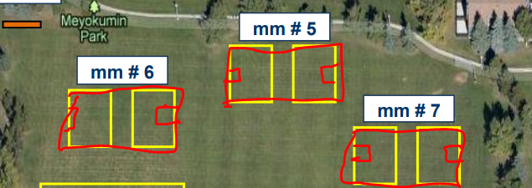

- For the U7 B (Mon/Wed), when it comes to the last activity (small sided game), play the team beside you but make the field larger as per the diagram:
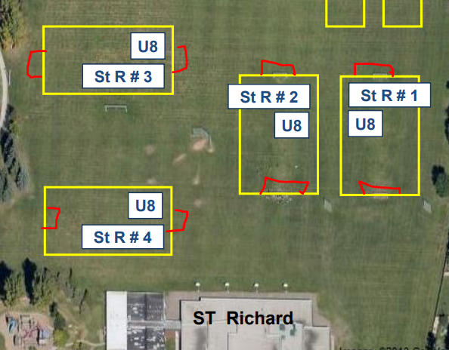
- For the U4/U5 teams, when it comes to the last activity (small sided game), play the team beside you but only play 3 v 3 staying on a mini field.
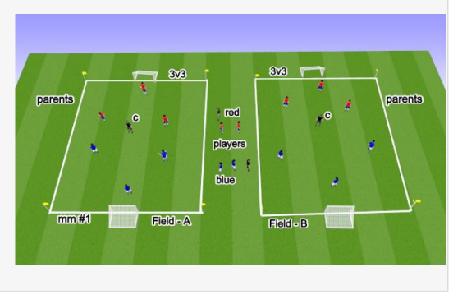
PLEASE NOTE: THE FIELDS ARE ONLY TO BE SHARED WHEN IT IS TIME FOR THE SMALL SIDED GAME. ALL TEAMS MUST STAY ON THEIR OWN MINI FIELD FOR THE FIRST 3 ACTIVTIES.
The purpose of this is more touches on the ball. If a player only touches the ball twice in the hour, they are not developing their skill for the game. Also, no one wants to stand around watching while one or two players bull doze down everyone.
We hope this new format will be an improvement. As we stated earlier, we are constantly tweaking this program and learning. We appreciate the feedback from everyone.
If you have any questions or concerns, please contact Mary at techmaryh@gmail.com
Thank you,
Mill Woods Soccer

